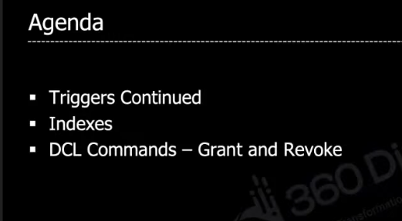

**Example query for trigger:**

Assum below is the record we have in employee table,

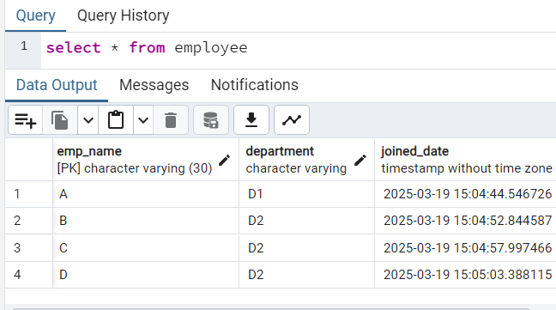

when ever we updates particular record the joined date will not be updated to current time, to update it we can use functions to trigger before updated or after update.

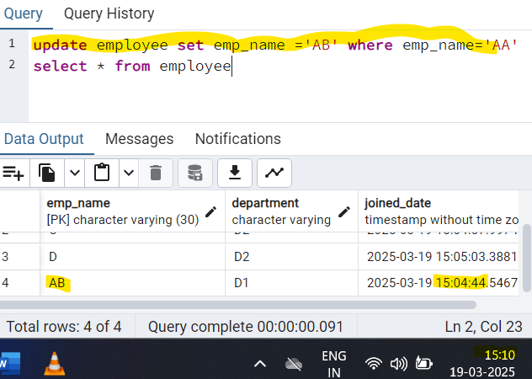

**CREATING FUNCTION**

Creating function may vary from Data base application.

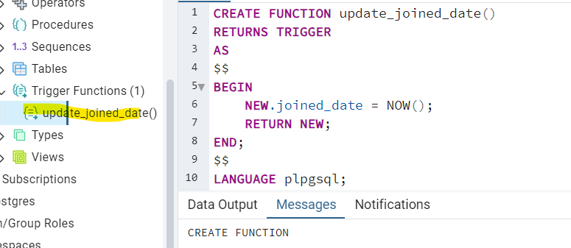

**CREATING TRIGGER**

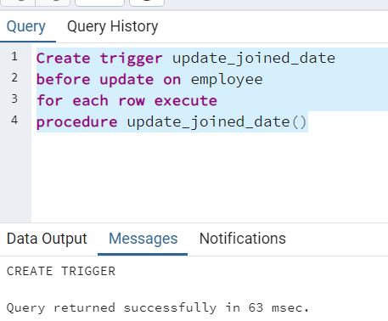

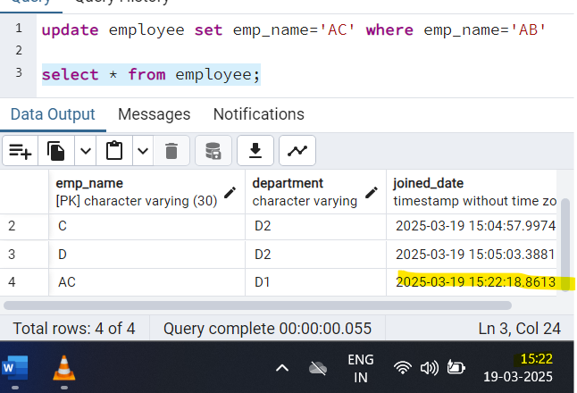

**Explain command in mysql (EXTRA)**

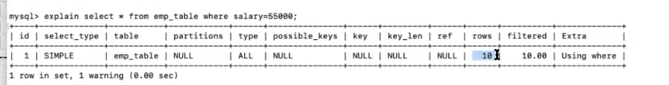

**INDEX:**

It is way to helps to retrieve a record from millions of data in a optimized way, it is also created using create statement, index are stored to the specified column when it is created, before going to put index on specified column it sorts the column first and the puts the order of sorting position like the below image.

Assum we created index for salary column in below image

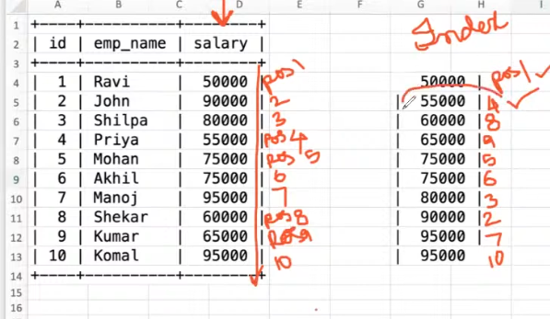

Without these index query will process whole record in a table

The row below query looked in one after putting index. Before this it looks for 10 rows

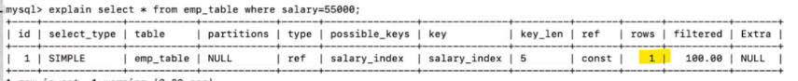

**CREATING INDEX**

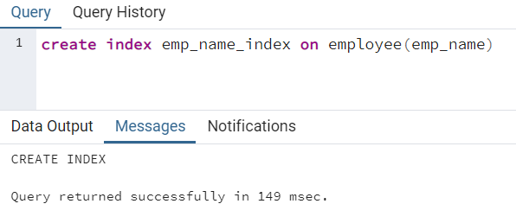

Before index it take 200

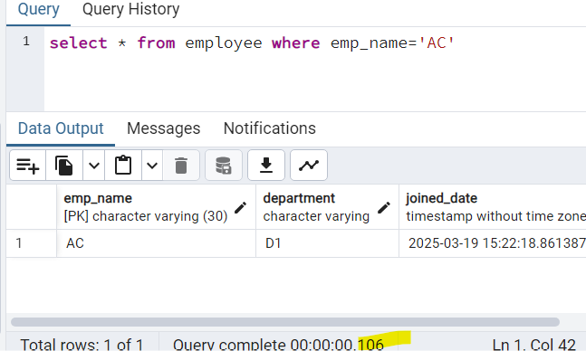

**DROP Index**

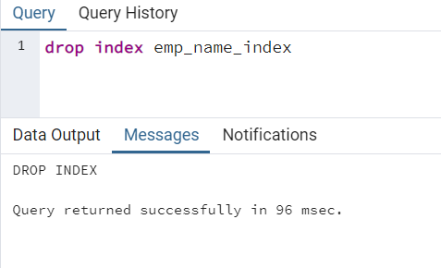

**DCL COMMANDS**

1. Grant - The permission given to the database to manipulate it
2. Revoke

We can create users



Switch to new created user

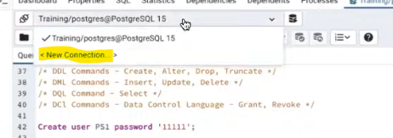

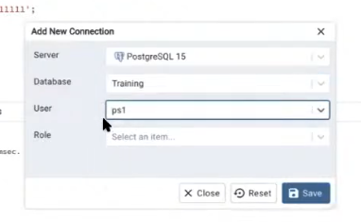

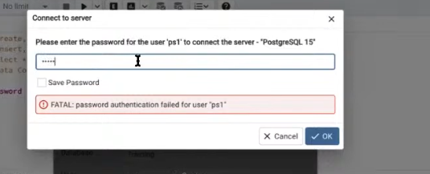

**GRANT permissions to New user**

For this we have to login to super user

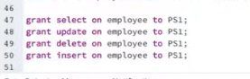



**Revoking permissions**

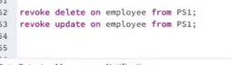

**DROP User**

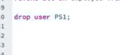

All the logined in users can be seen here

